**PROGRAMMING ASSIGNMENT 1.**

**NAME: JETHWA, DEVYAN AMRISH**

**ID: 183428**

**Compilers used: Programiz and Codeblocks.**

**EMAIL:** [**Devyan.jethwa@strathmore.edu**](mailto:Devyan.jethwa@strathmore.edu)

**TEST OUTPUT 1:**

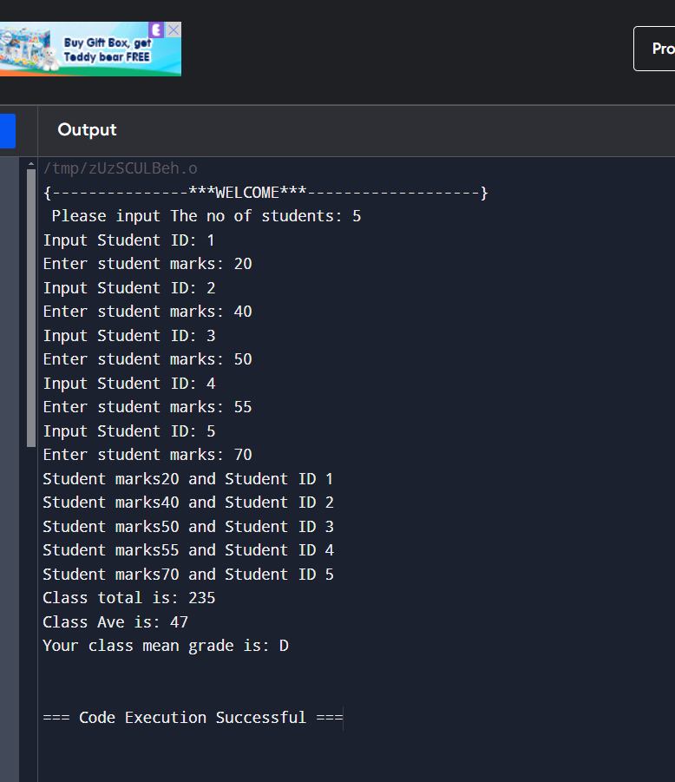

**TEST OUTPUT 2:**

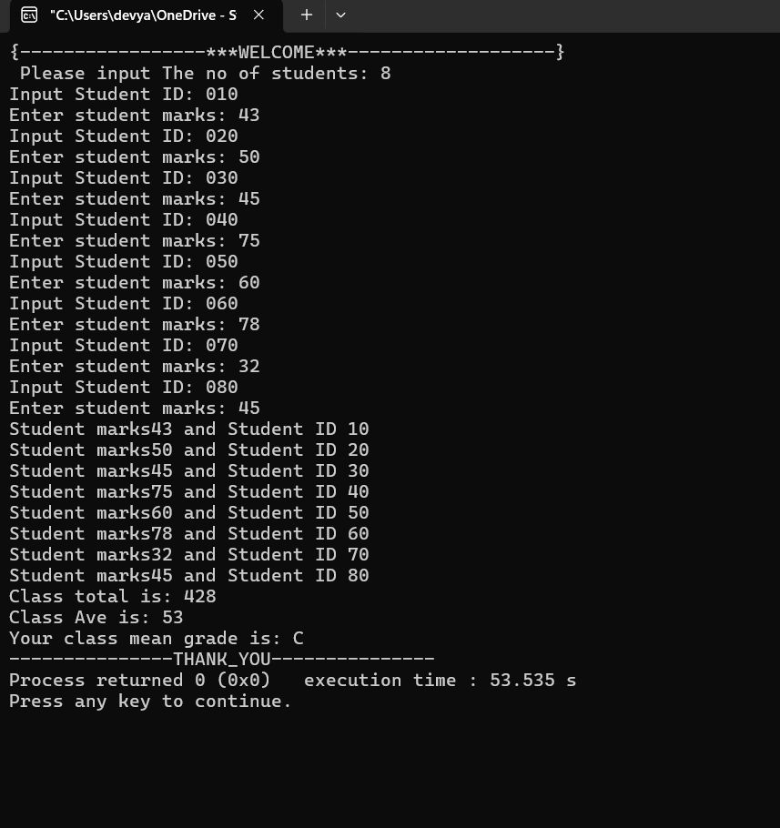

**ERROR CHECKING:**

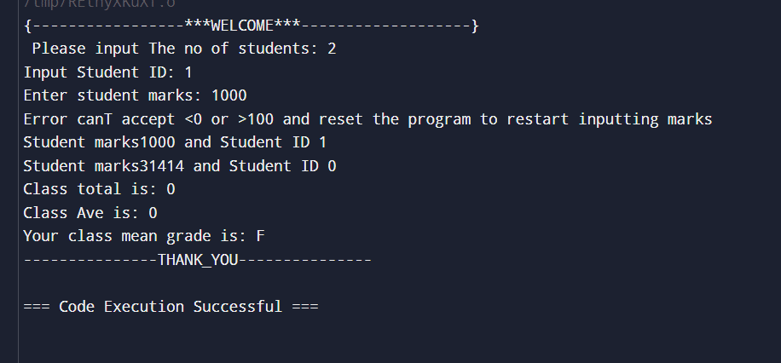

**CODE:**

#include <iostream>

using namespace std;

int main(){

int marks[80];

int id[80];

int n;

int total;

double ave;

char grade;

//no.of students

cout<<"{-----------------***WELCOME***-------------------} "<<endl;

cout<<" Please input The no of students: ";

cin>>n;

for(int i=0;i<n;i++)

{

cout<<"Input Student ID: ";

cin>>id[i];

cout<<"Enter student marks: ";

cin>>marks[i];

if (marks[i]<0||marks[i]>100)

{

cout<<"Error canT accept <0 or >100 and reset the program to restart inputting marks"<<endl;

break;

}

total=total+marks[i];

}

for(int i=0;i<n;i++)

{

cout<<"Student marks"<<marks[i]<<" and "<<"Student ID "<<id[i]<<endl;

}

cout<<"Class total is: "<<total<<endl;

ave=total/n;

cout<<"Class Ave is: "<<ave<<endl;

if (ave<0||ave>100){

cout<<"INVALID ANSWER";

}

else if (ave<=39)

{

grade='F';

cout<<"Your class mean grade is: "<<grade<<endl;

}

else if (ave<=49){

grade='D';

cout<<"Your class mean grade is: "<<grade<<endl;

}

else if (ave<=59){

grade='C';

cout<<"Your class mean grade is: "<<grade<<endl;

}

else if (ave<=69){

grade='B';

cout<<"Your class mean grade is: "<<grade<<endl;

}

else if (ave>=70){

grade='A';

cout<<"Your class mean grade is: "<<grade<<endl;

}

cout<<"---------------THANK_YOU---------------";

return 0;

}